RAJALAKSHMI ENGINEERING COLLEGE
Department of Artificial Intelligence and Machine Learning

AD23632 – FRAMEWORK FOR DATA AND VISUAL ANALYTICS

MINI PROJECT
SPORTS ANALYTICS

Submitted in partial fulfilment of the requirements for the course
Framework for Data and Visual Analytics

Submitted by
Name: SRIVAISHNAVI N
Register Number: 241501217
Department: Artificial Intelligence and Machine Learning
Rajalakshmi Engineering College

Submitted to
Faculty Name: AKSHAYA V

Academic Year: 2026–2027

TABLE OF CONTENTS

Abstract…………………………………………………………………...3
Chapter 1: Introduction…………………………………………………...4
Chapter 2: Tools and Technologies Used………………………………...6
Chapter 3: Dataset Description…………………………………………...7
Chapter 4: Methodology………………………………………………….8
Chapter 5: Power BI Dashboard and Visualizations……………………..10
Chapter 6: Results and Discussion……………………………………….11
Chapter 7: Advantages, Limitations and Future Enhancements………….12
Chapter 8: Dashboard Output and Conclusion……………………………13

ABSTRACT
The Sports Analytics project analyzes cricket match records using a structured CSV dataset and Microsoft Power BI. The uploaded dataset contains 1,107 match records spanning 2008 to 2025. It includes season, participating teams, toss information, innings scores, match results, venues, and player-of-the-match details.
The Power BI report contains three pages. The first summarizes match counts and seasonal activity. The second compares match winners and player-of-the-match awards. The third examines toss decisions and toss winners. The project demonstrates how visual analytics can help users explore seasonal activity, team outcomes, player awards, and toss patterns.
Keywords: Sports Analytics, Cricket, Power BI, Data Visualization, Match Analysis, Toss Analysis.

CHAPTER 1: INTRODUCTION

1.1 Introduction
Sports analytics applies data analysis and visualization to performance records, match outcomes, and sporting information. This project uses a CSV dataset of cricket matches and a Power BI report to summarize seasonal activity, winning teams, player awards, and toss-related decisions.

1.2 Problem Statement
Match datasets contain many rows and attributes. Reviewing them manually makes it difficult to compare seasons, teams, and match decisions. A visual analytics solution helps summarize records and present comparisons clearly.

1.3 Objectives
- Explore the cricket match dataset and its attributes.
- Summarize the number of matches and seasons represented.
- Compare match wins across teams.
- Examine player-of-the-match award counts.
- Analyze toss decisions and toss winners.
- Build a multi-page Power BI report.

1.4 Scope of the Project
The analysis covers 1,107 records, 18 seasons, 15 distinct team names across team columns, 18 venues, and 17 cities as represented in the supplied CSV. Results describe this dataset and are not a live score feed.

CHAPTER 2: TOOLS AND TECHNOLOGIES USED

2.1 Microsoft Power BI
Power BI is used to create interactive report pages and visualizations. The supplied PBIX file includes cards, a line chart, clustered column and bar charts, a donut chart, and a pie chart.

2.2 CSV Dataset
The dataset is stored in CSV format, which can be inspected using spreadsheet software, Python libraries, and Power BI.

2.3 Python and Pandas
Python and Pandas can be used to inspect the dataset, check data types, detect missing or duplicate rows, and calculate summary statistics.

2.4 Technologies Summary
Technology | Purpose
CSV | Stores match data in rows and columns.
Microsoft Power BI | Creates cards, charts, and report pages.
Python | Supports data inspection and preprocessing.
Pandas | Loads and summarizes the CSV dataset.

CHAPTER 3: DATASET DESCRIPTION

3.1 Dataset Overview
The file final_matches.csv contains 1,107 rows and 25 columns. Dates range from 2008-03-13 to 2025-07-29. The dataset includes match identification, season, venue, teams, toss information, innings scores, result details, winner, and player-of-the-match fields.

3.2 Important Attributes
Attribute | Description
match_id | Identifier for a match record.
season | Season or year associated with the match.
date | Date associated with the match.
venue / city | Ground and city associated with the match.
team1 / team2 | Teams participating in the match.
toss_winner / toss_decision | Recorded toss winner and decision.
innings scores | Recorded first- and second-innings scores.
result / win_by / win_margin | Match result and winning margin details.
winner | Team recorded as the match winner.
player_of_match | Player named for the match award.

3.3 Dataset Quality Checks
Basic inspection found 0 missing cells and 0 fully duplicated rows in the supplied final_matches.csv. These checks do not guarantee that every value is semantically valid.

CHAPTER 4: METHODOLOGY

4.1 Project Workflow
Dataset → Data Inspection → Data Preparation → Power BI Import → Visualizations → Interpretation

4.2 Data Inspection and Preparation
- Load the CSV dataset and inspect rows and columns.
- Check column names, data types, missing values, and duplicate records.
- Confirm season, team, toss, winner, and player-award fields.
- Aggregate records by season, winner, player-of-the-match, and toss categories.
- Build report visuals in Power BI.

4.3 Dashboard Development
The supplied PBIX file contains three report pages. The visuals use match counts by season, winner, player-of-the-match, toss decision, and toss winner.

4.4 Interpretation
The visuals compare seasonal match counts, team winner counts, player award counts, and toss decision patterns.

CHAPTER 5: POWER BI DASHBOARD AND VISUALIZATIONS

5.1 Dashboard Overview
Page | Visual | Suggested title
Page 1 | Card using match_id | Total Matches
Page 1 | Card using season | Season Count (verify aggregation)
Page 1 | Line chart | Number of Matches by Season
Page 2 | Column chart | Matches Won by Team
Page 2 | Donut chart | Distribution of Match Winners
Page 2 | Bar chart | Player of the Match Awards
Page 3 | Donut chart | Toss Decision Distribution
Page 3 | Column chart | Toss Wins by Team
Page 3 | Pie chart | Bat or Field: Toss Decision

5.2 Page 1: Match Overview and Seasonal Trend
The first page contains two cards and a line chart. In the supplied CSV, 2025 has the highest number of records (73).
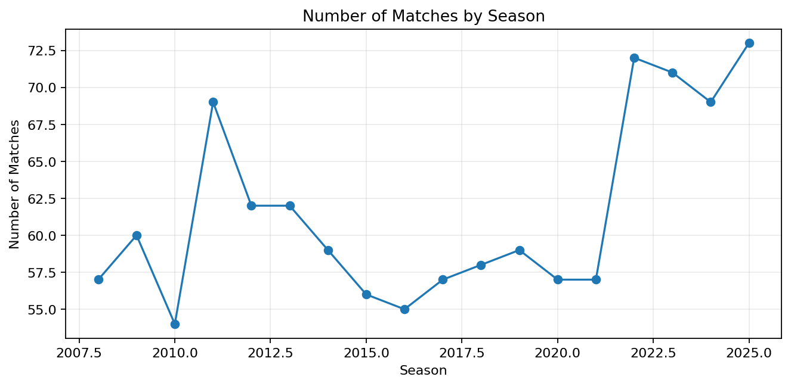

5.3 Page 2: Match Winners and Player Awards
The second page compares winner counts and player-of-the-match awards. The most frequent value in the winner field is Royal Challengers Bengaluru with 141 records.
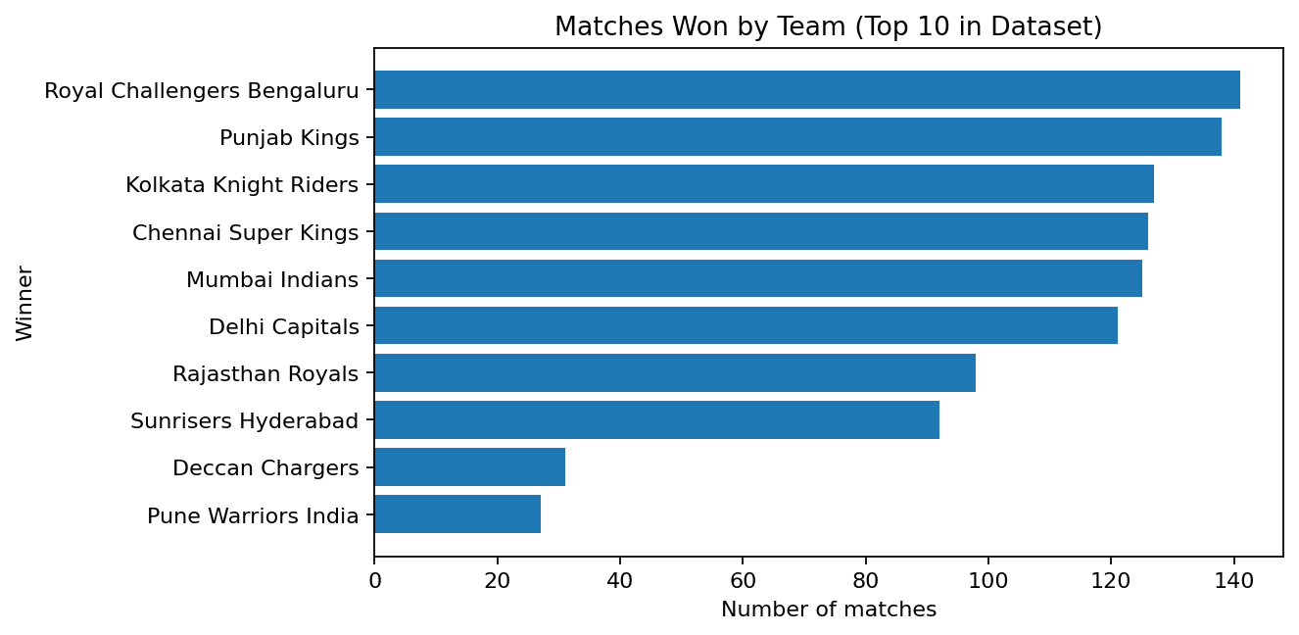
The most frequent player-of-the-match name in the supplied file is Martin Gill, appearing 9 times. These are dataset values and have not been independently verified.
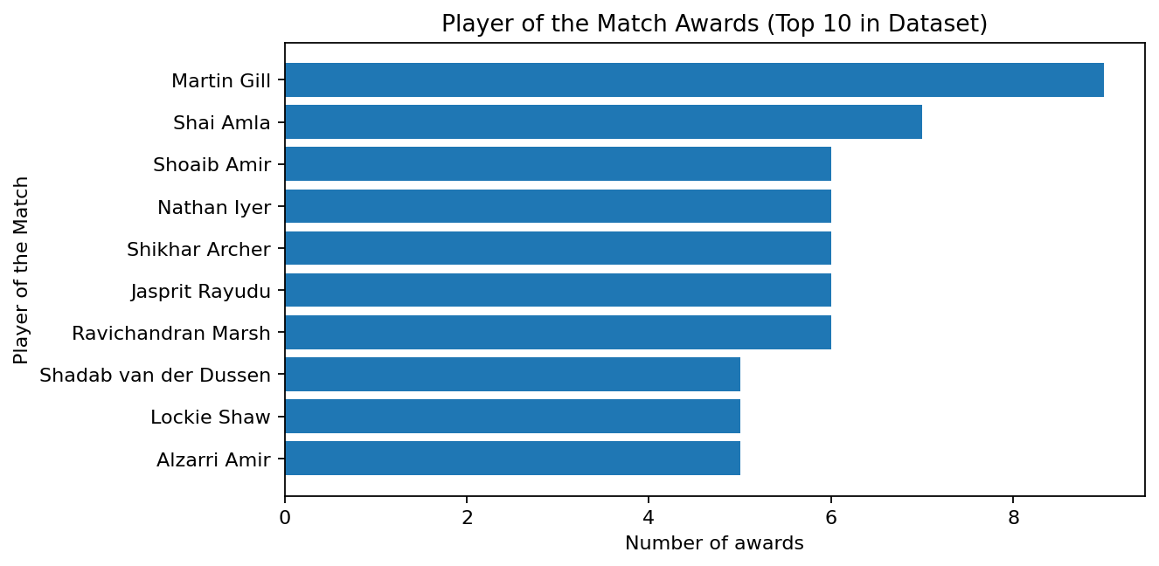

5.4 Page 3: Toss Analysis
The toss decision field records 584 decisions as bat and 523 as field.
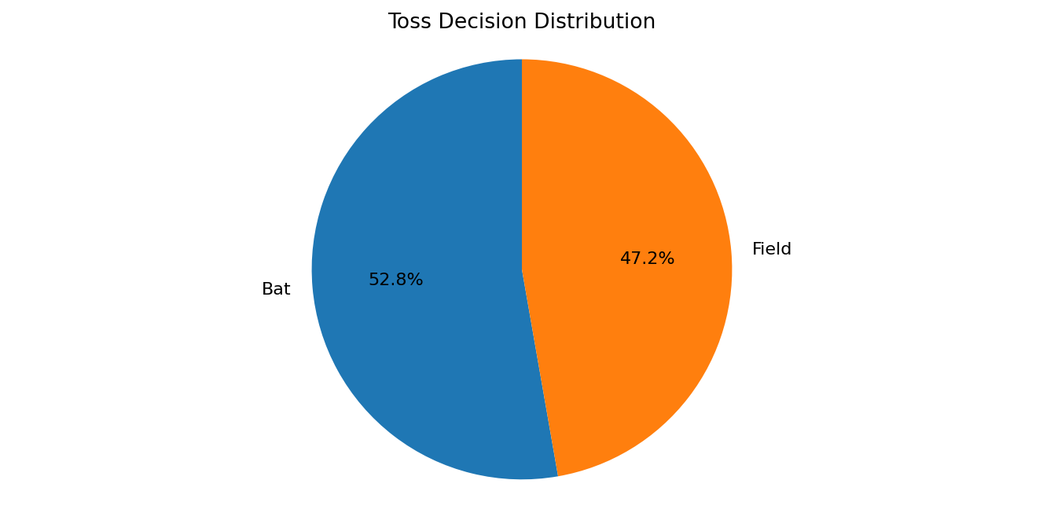
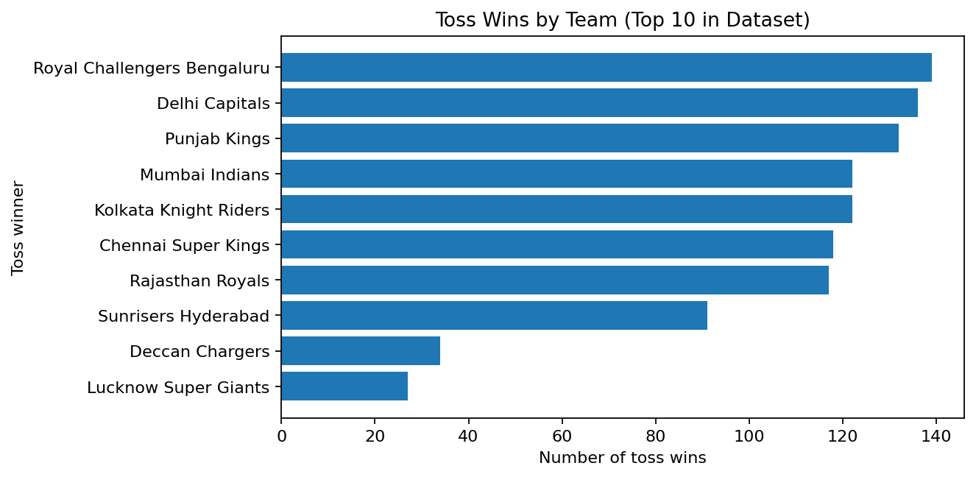

5.5 How to Add Titles in Power BI
- Select a visual on the report canvas.
- Open Format visual (paintbrush icon).
- Expand General, then Title.
- Switch Title to On and enter the suggested title.
- Adjust font, alignment, and colour.

CHAPTER 6: RESULTS AND DISCUSSION

6.1 Results
- The supplied CSV contains 1,107 records across 18 seasons (2008–2025).
- There are 15 distinct team names across team1 and team2.
- Royal Challengers Bengaluru is the most frequent winner-field value (141 records).
- Martin Gill is the most frequent player-of-the-match value (9 records).
- Toss decisions are bat (584) and field (523).
- 2025 has the highest record count (73).

6.2 Discussion
The dashboard combines seasonal, team, player-award, and toss information. These findings are descriptive and do not establish why a team won or whether toss decisions caused match outcomes.

CHAPTER 7: ADVANTAGES, LIMITATIONS AND FUTURE ENHANCEMENTS

7.1 Advantages
- Summarizes match records visually.
- Makes season-wise comparisons easier.
- Compares winner and toss-related categories.
- Highlights player-of-the-match counts.
- Provides a multi-page report in Power BI.

7.2 Limitations
- Results depend on the supplied dataset's correctness.
- Counts alone do not explain the causes behind outcomes.
- Team and player names may require validation and standardization.
- The dashboard is not live unless connected to an updating source.
- A high win count should be considered alongside matches played.

7.3 Future Enhancements
- Add slicers for season, team, venue, and result type.
- Add win percentage and matches-played measures.
- Compare batting-first and fielding-first outcomes.
- Analyze win margin and innings score distributions.
- Validate team and player names.
- Add drill-through pages for individual teams or seasons.

CHAPTER 8: DASHBOARD OUTPUT AND CONCLUSION

8.1 Dashboard Output
Insert screenshots from your actual Power BI report before submitting. Capture one screenshot for each report page.
Screenshot | What it should show
Page 1 | Match overview cards and Number of Matches by Season.
Page 2 | Matches Won by Team, Distribution of Match Winners, and Player of the Match Awards.
Page 3 | Toss Decision Distribution and Toss Wins by Team.

8.2 Conclusion
The Sports Analytics project demonstrates how cricket match data can be explored and summarized using Microsoft Power BI. The report presents seasonal match counts, match winners, player-of-the-match awards, toss decisions, and toss winners through visualizations.
The project provides practical experience in dataset inspection, aggregation, visual analytics, and dashboard presentation. Findings remain limited to the records and fields available in the supplied dataset.
Submission reminder: Replace the blank student and faculty details on the cover page, verify the second card's aggregation in Power BI, and add screenshots of your own dashboard before final submission.

